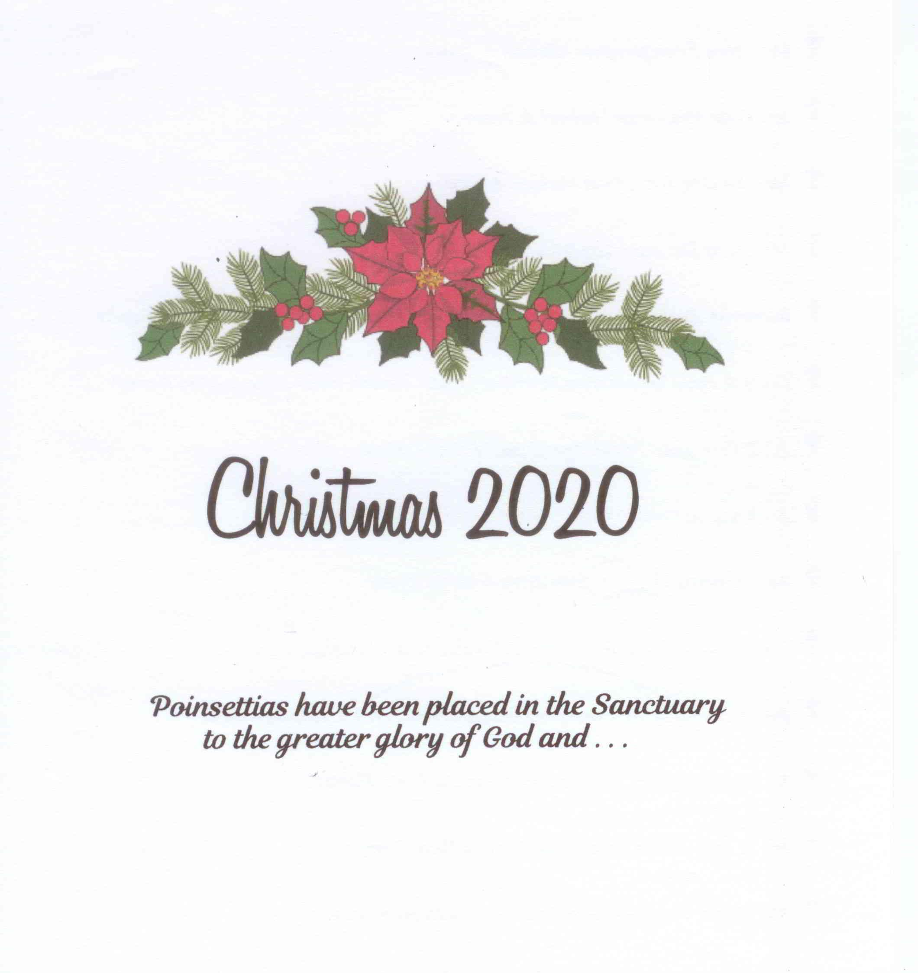

Christmas 2024

Poinsettias have been placed in the Sanctuary

to the greater glory of God and . . .

**In Honor of:**

🕆 *Our Pastor, Staff, and Church Family by Jerry and Sarah Dyess*

🕆 *Our grandsons Eli, Logan, and baby Frank by Frank and Kay Dobson*

🕆 *Haniel, Judy and Kenny Croft by the Barnes Family*

🕆 *Roy and Jeanette Adams by Bill and Michelle Rainey*

🕆 *Peggy Rainey by Bill and Michelle Rainey*

🕆 *Carol Cobb by Bill and Michelle Rainey*

🕆 *Virginia McQueen by Bill and Michelle Rainey*

🕆 *Marvin Skinner by Bill and Michelle Rainey*

**In Memory of:**

**** *Our Parents, Jack and Bertie Brewster and*

*Fred and Sallie Dyess by Jerry and Sarah Dyess*

**** *Mr. & Mrs. Robert Morrison by The Jim Davis Family*

** **

**** *Mr. & Mrs. James Davis by The James Davis Family*

**** *Mr. & Mrs. Ralph Lazenby by The Jim Davis Family*

**** *James A. Dean by Mary Carole Dean*

**** *Marcus and Doug Chandler by Bonnie Chandler*